• **Step 1:** Import HttpClientModule into the AppModule to enable HTTP services.

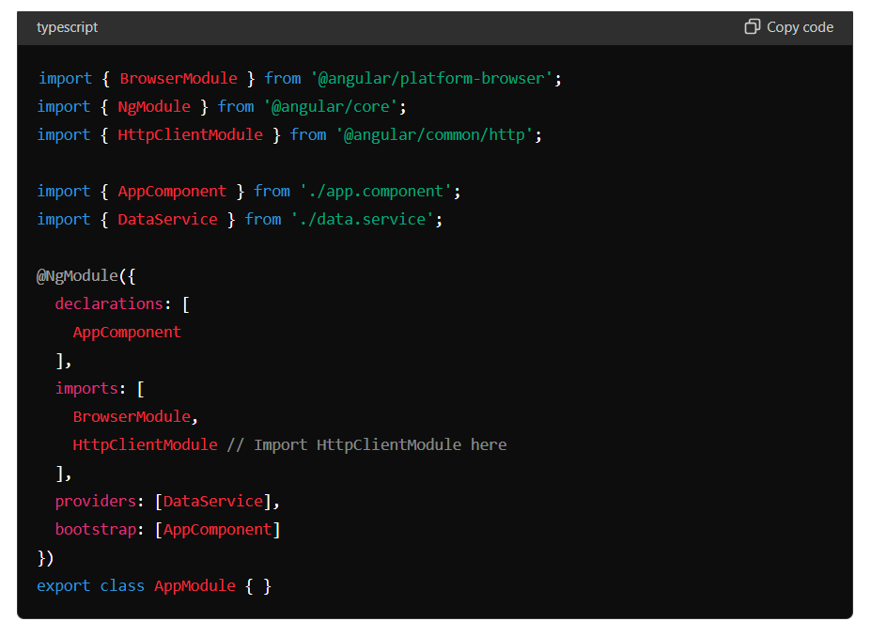

• **Step 2:** Create a DataService that uses HttpClient to fetch data from an API endpoint.

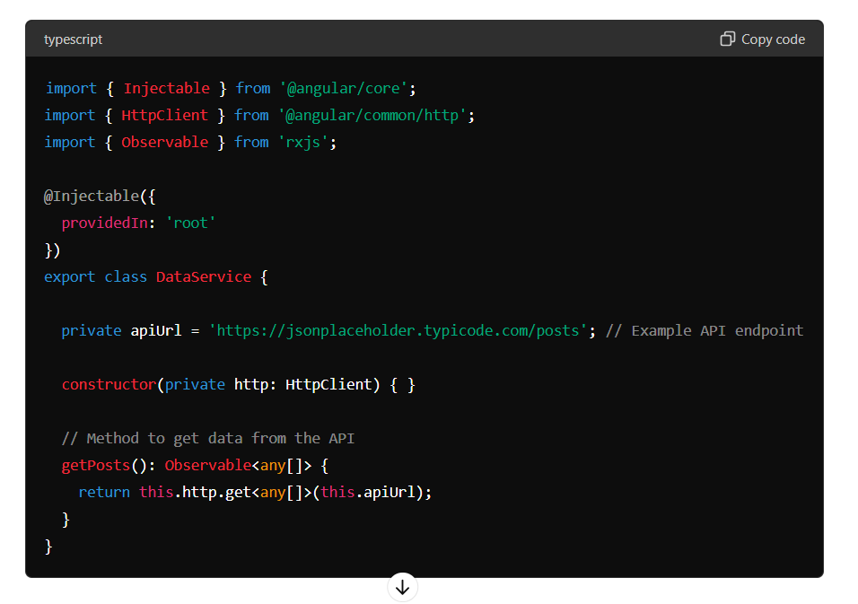

• **Step 3:** Inject DataService into a component and call its getPosts method to fetch data and display it in the template using Angular's data binding features.

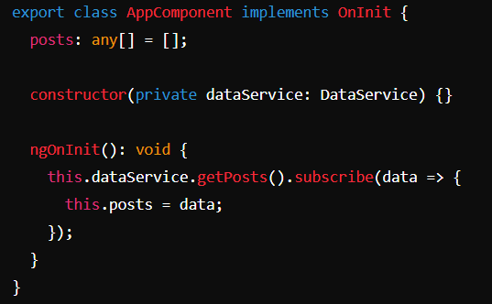

@NgModule is a decorator in Angular that marks a class as an Angular module. Angular modules help organize an application into cohesive blocks of functionality. An Angular module can contain components, directives, pipes, and providers, and it can also import other modules.

**@NgModule**

@NgModule is a decorator in Angular that marks a class as an Angular module. Angular modules help organize an application into cohesive blocks of functionality. An Angular module can contain components, directives, pipes, and providers, and it can also import other modules.

Here's a simple explanation of its key properties:

* **declarations**: This property lists the components, directives, and pipes that belong to this module.
* **imports**: This property lists other modules whose exported classes are needed by components in this module.
* **providers**: This property lists the services available in the application.
* **bootstrap**: This property lists the root component that Angular should bootstrap when it starts the application.

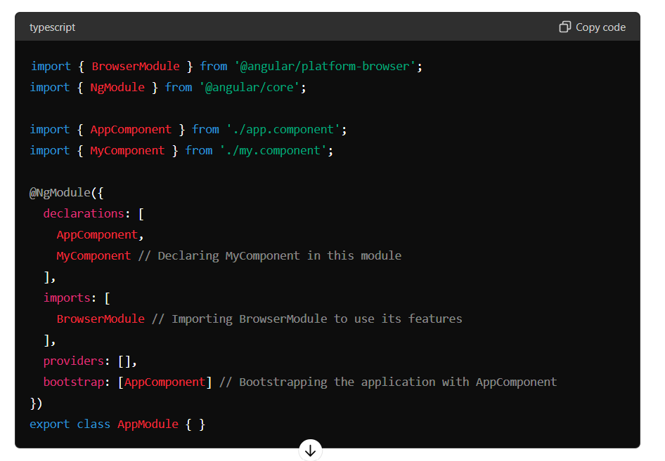

**@Injectable :**

@Injectable is a decorator that marks a class as available to be provided and injected as a dependency. The providedIn property configures how the service should be provided in the dependency injection system.

When you set providedIn: 'root', it means that the service is registered as a singleton and is available throughout the application. This is the recommended way to provide services, as it ensures the service is included in the application bundle only once and is available everywhere.

Example:

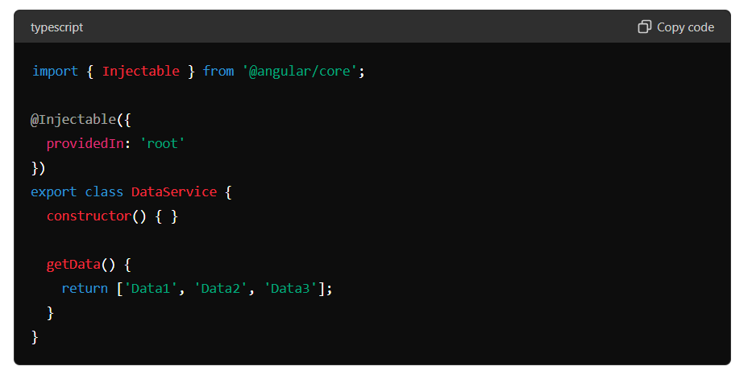

**@Injectable({ providedIn: 'root' })**: This makes DataService available throughout the application without needing to explicitly add it to the providers array in a module. It ensures the service is a singleton and can be injected anywhere in the app.